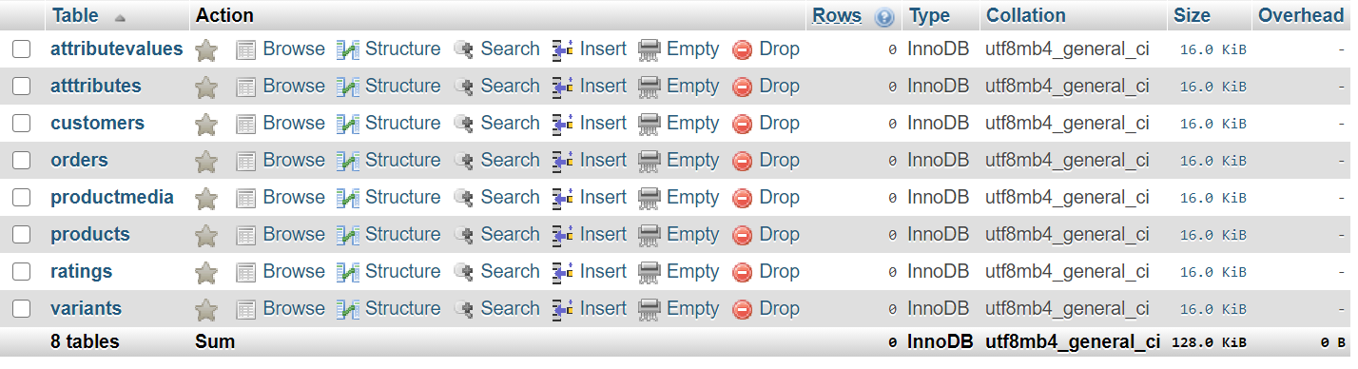

1. Get all the variants by product id

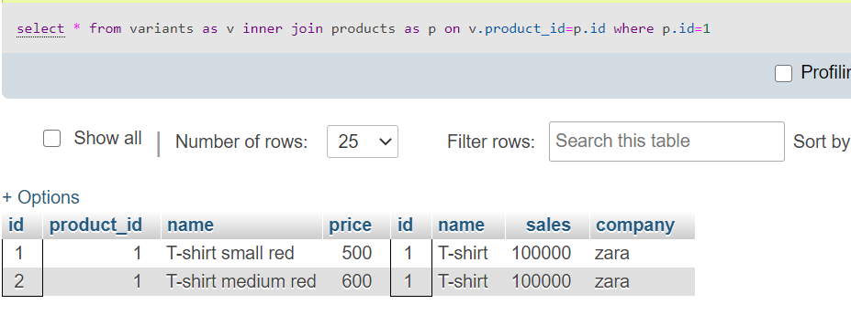

1. Get product details by particular variant id

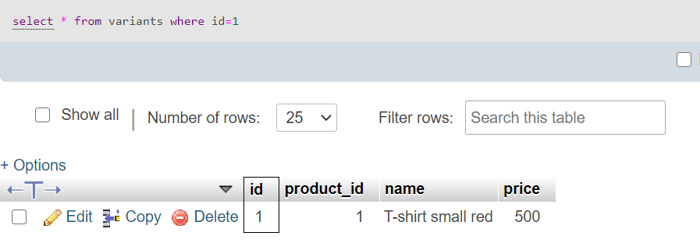

1. Write a query to insert a varient inside a product

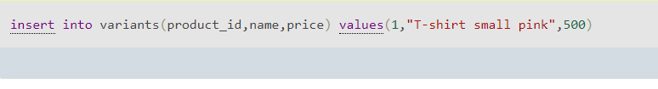

1. Get media of a particular variant

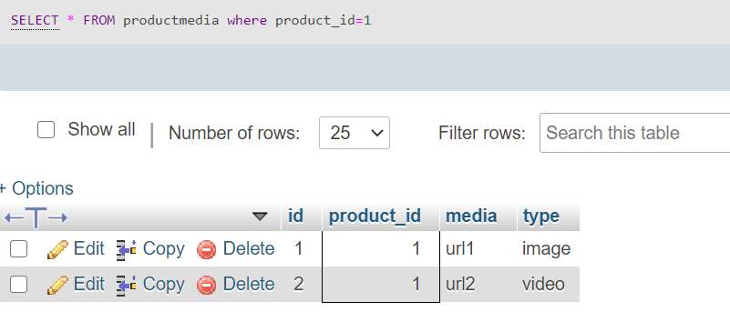

1. Get average rating of a product by id

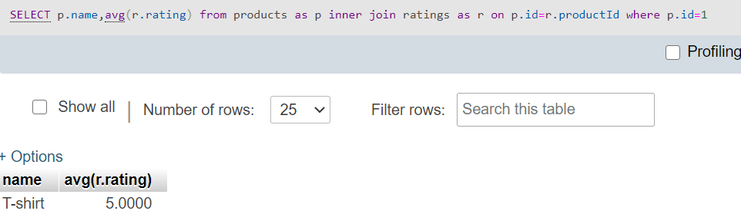

1. Fetch all order by customer id

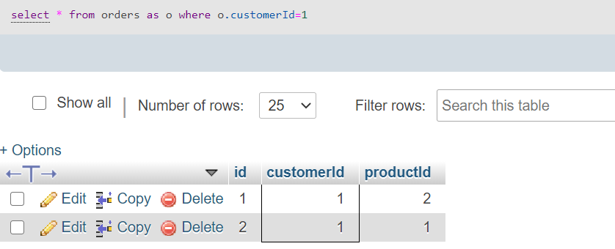

1. Get total number of sales by product Id

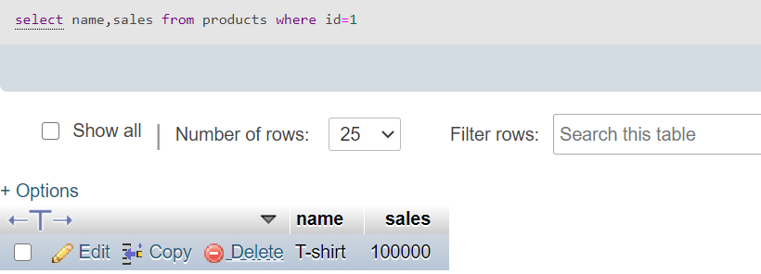

1. Get total number of sales value for over all company

